- Result of Nmap Scan of my ip address.
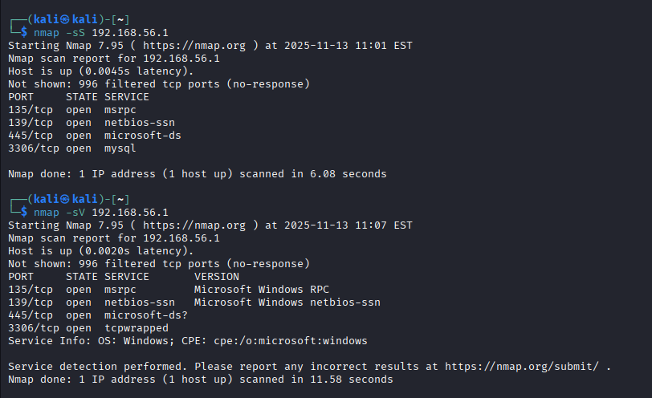
- Potential security risks from open ports.
1. Understand What Each Port Means (Risk Level)
135 – Microsoft RPC (High Risk)
Used by Windows Remote Procedure Call.
Attackers use it for DCE/RPC exploits, lateral movement.
Common in WannaCry, Conficker, EternalBlue family.
➡ Risk: High
➡ Why: Often targeted for remote code execution (RCE).

---

- 137, 138, 139 – NetBIOS (Very High Risk)

Used for Windows file sharing before SMB2.

Exposes:

Computer name

Users

Shared folders

Domain/workgroup information

➡ Risk: Very High
➡ Why: Can leak system info, allow enumeration (nbtscan, smbclient, enum4linux).

---

- 445 – SMB / Microsoft-DS (Extremely High Risk)

This is the most dangerous open port on Windows.

Used for SMB file sharing.

Vulnerable historically (and still in many systems):

EternalBlue

WannaCry

SMBv1 vulnerabilities

Allows:

Password brute-force

Share enumeration

Exploits (Metasploit modules)

➡ Risk: Severe
➡ Why: Remote Code Execution (RCE) possible.

---

- 3306 – MySQL Database (High Risk)

If MySQL is exposed:

Attackers can brute-force SQL credentials.

If password is weak → database takeover.

SQL injection testing possible.

Sensitive data exposure risk.

➡ Risk: High
➡ Why: Database compromise likely.

---

